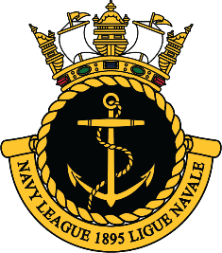
NAVY LEAGUE OF CANADA HONOURS AND AWARDS
Announcement of The Vice-Admiral (Ret’d) Peter Cairn, CMM, CD, Leadership Award
Generously sponsored by Heddle Marine
Call for submissions
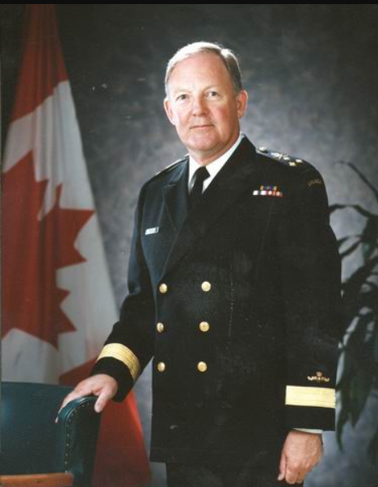
The Vice-Admiral (Ret’d) Peter Cairns Award is created to recognize and honour a Canadian innovator and trailblazer in the shipbuilding industry who has made an inspiring contribution to Canada, the Canadian Marine sector and the Canadian shipbuilding industry.
Vice-Admiral(Ret’d) Cairns joined the Royal Canadian Navy in 1956 and assumed his first Command of HMC Submarine Onondaga in 1972, and later, became Commander of the First Canadian Submarine Squadron in 1974. He subsequently commanded HMC Ships Fraser, Margaree and Assiniboine.
His last appointments were as Commander Maritime Forces Pacific in 1989 and as Commander Maritime Command in 1992 before he retired in 1994.
In 1998 after a brief period with SPAR AEROSPACE, Vice-Admiral (Ret’d) Cairns went onto lead the Shipbuilding Association of Canada as its President for 20 years. During his tenure Vice-Admiral (Ret’d) Cairns was dedicated and persistent in his advocacy to the government of Canada for a national policy on federal shipbuilding. Under his leadership and articulation of Canada’s need for a modern navy and a sustainable industry, the National Shipbuilding Procurement Strategy was born. Later re-named the National Shipbuilding Strategy (NSS) it went onto be the policy framework for the award of combat and non-combat ships worth over $100B.
Under his tenure as the President of the Shipbuilding Industry Association for 20+ years, Vice-Admiral (Ret’d) Cairns was instrumental in the development and enablement of the most substantial marine industrial policy development in Canada since WWII.
In the years to come, as a result of his dedicated and persistent leadership, the Canadian government will make its single largest investment since Confederation of over $100B into the fleet renewal of Royal Canadian Navy (RCN) and Canadian Coast Guard.
This recapitalization of Canada’s federal fleets, will not only replace Canada’s ageing combat fleet, and create a new level of ice-breaking and rescue capability for Canada it will establish a vibrant and modern shipbuilding industry, in Canada, for future generations.
Vice-Admiral (Ret’d)Cairns stewardship and persistence in his associations and participation in the development and championship of the National Shipbuilding Strategy will ultimately provide stability for the marine sector, the RCN, the Coast Guard, and the maritime community in Canada.

WHO IS ELIGIBLE FOR THIS AWARD
This award is open to a broad range of influencers and stakeholders in Canada’s marine sector. Candidate eligibility is open to;
- Military officials
- Government members
- Industry members
- Academia
- Retired influencers

DUE DATE: February 1st, 2023
All submissions should be completed and submitted to Maritime Affairs Navy League of Canada (maritimeaffairs@navyleague.ca) no later than February 1st, 2023. Attention to Committee Chair Mme Louise Mercier.

2022/2023 SELECTION CRITERIA –
To celebrate Vice-Admiral (Ret’d) Peter Cairns, as a leader, and as an innovator, this award pays tribute to his leadership to the marine sector and resilience in the face of political, bureaucratic and competitive challenges that persisted in the effort of creating harmony for the sake of a long-term industrial strategy. These were leadership principles he exercised in his 20-year effort to secure a long-term strategy for Canada.

A candidate for the Vice-Admiral (Ret’d) Peter Cairns Leadership Award demonstrates the following leadership principles in the Canadian marine sector:
- Collaboration, Innovation, Loyalty, & Persistence.
- Innovation and/or thought leadership in the marine sector
- Championing the industry
- Serves as an inspiration for others

NOMINATION SUBMISSION
Nominations are to contain the following documentation.
- Nomination Form –
- Nomination letter (2 pages max)
- Nominee’s Curriculum Vitae / biographical summary
- Letters of support

NOMINATION REQUIREMENTS
Nominators are responsible for ensuring that the file is complete and that the information it contains is accurate and sufficient to allow the Award Selection Committee to fairly evaluate the nomination.
While the nomination file must be complete in itself, the Navy League of Canada, Maritime Affairs Selection Committee reserves the right to have the main facts in support of a nomination validated by an outside source, should they deem necessary.
All submissions are considered in confidence by the Navy League of Canada, Maritime Affairs and the Vice Admiral (Ret’d) Peter Cairns Leadership Award Selection Committee, and nominations will not be publicly disclosed. Nominations are accepted in both official languages.
NOMINATION PROCEDURE
ELIGIBLE AWARD RECIPIENTS’ REQUIREMENTS
The award will be presented in Ottawa in 2023 at the Annual Navy /Coast Guard Appreciation Day Ceremony as a finale to celebrate the cumulative efforts of the Navy League of Canada Celebration of the RCN and the Coast Guard Day to acknowledge Vice Admiral Peter Cairns. It is highly desirable that the recipient attend the Conference Presentation in Ottawa, ON.

SELECTION PROCESS
BROUGHT FORWARD NOMINATIONS
In addition to initiating the nomination process government and industry wide, should the selection be limited, the Navy League of Canada reserves the right to bring forward past nominations for current year consideration to the Award Selection Committee, when they deem fit, for a period of 2 years post original nomination.
SELECTION COMMITTEE
To ensure that the standards for this prestigious award are maintained in accordance with the highest levels possible, a Selection Committee will be struck by the Navy League of Canada Maritime Affairs and shall include a representative of Heddle Marine, members of the Navy League of Canada board and distinguished members of the Canadian marine community,
SELECTION COMMITTEE RESPONSIBILITIES
The Navy League of Canada Board of Directors along with external partners will be solely responsible for selecting the laureate, ensuring the recipient falls within the outlined criteria and can perform as an active brand ambassador and partner for the marine and shipbuilding sector.
The Committee’s primary responsibilities is to review and discuss nominations with a view to arriving at consensus as follows:
selection of a primary nominee as the Award recipient.
- identification of an alternate nominee (should the primary be unable to accept);
- identifying nominees not selected but that warrant re-submission in future years.
2022 ADVISORY COMMITTEE –
- Mr. Shaun Padulo, Heddle Shipyards
- Vice-Admiral (Ret’d) Ron Buck, Past Chair Perley Rideau Health Centre
- Rear-Admiral (Ret’d) Andy Smith
- Capt(N) (Ret’d) Jay Plante
- Capt(N) (Ret’d) Ian Parker
- Commander (Ret’d) Brett Johnson. President, BJ Johnson & Associates
- Mr. Ray Sturgeon, President, ASSIG

